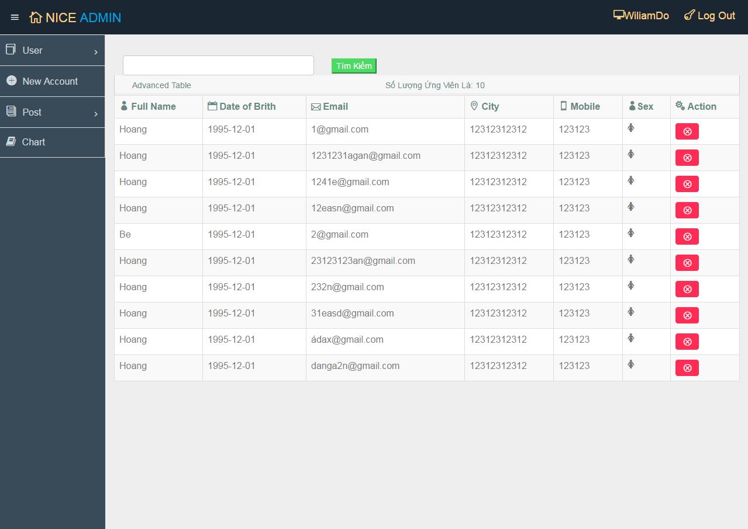

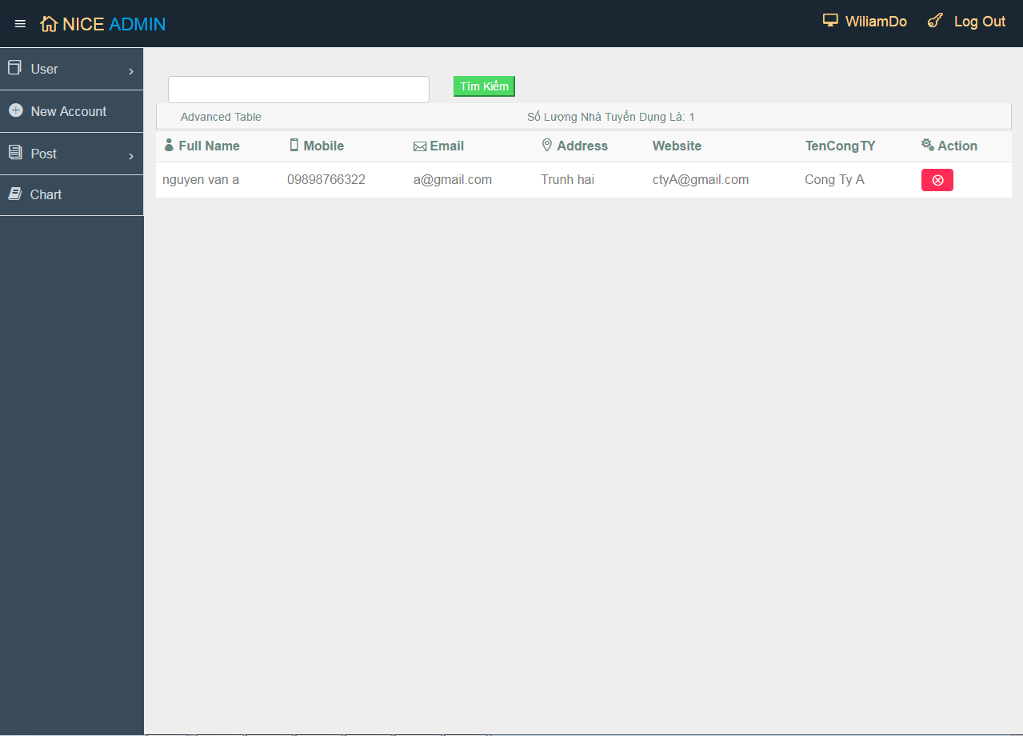

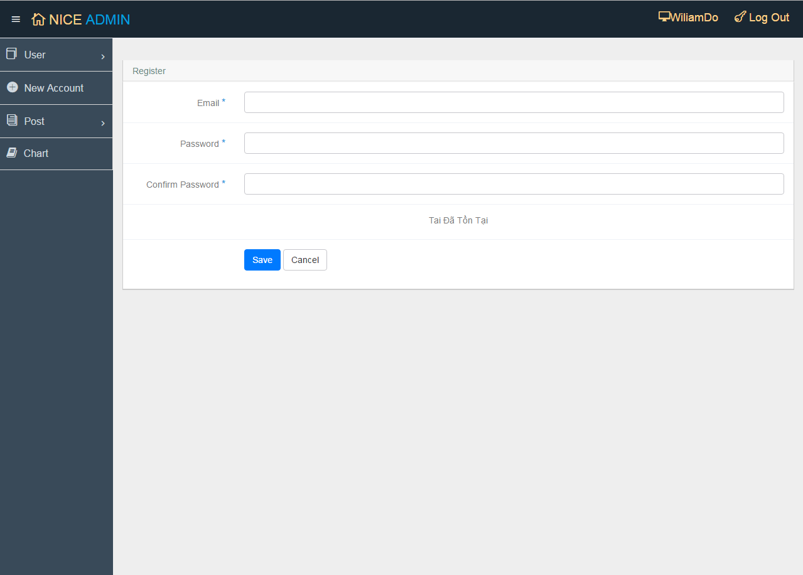

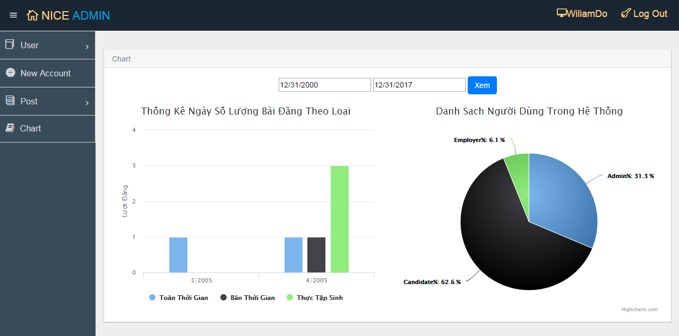

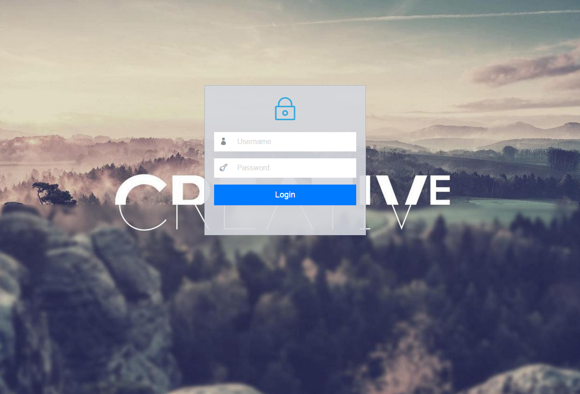

**From:** NguyenQuangVu [mailto:SVTT0117VuNQ@svtt.fsdn]   
**Sent:** Monday, March 27, 2017 4:09 PM  
**To:** SVTT0117ThanhDC@svtt.fsdn  
**Subject:**

Thanh c  h  o